**بنھا**

**جامعة**

**بشبرا**

**الھندسة**

**كلية**

**الجامعي**

**العام**

**٢٠١٩**

**-**

**٢٠٢٠**



Name

B.N:

Date:

Topic:

## Github link:

Github page:

University emailmailto:

Application Brief:-

Artificial intelligence (AI) refers to the simulation of human intelligence in machines that are programmed to think like humans and mimic their actions. The term may also be applied to any machine that exhibits traits associated with a human mind such as learning and problem-solving.

The ideal characteristic of artificial intelligence is its ability to rationalize and take actions that have the best chance of achieving a specific goal.

Artificial intelligence is based on the principle that human intelligence can be defined in a way that a machine can easily mimic it and execute tasks, from the most simple to those that are even more complex. The goals of artificial intelligence include learning, reasoning, and perception.

The applications for artificial intelligence are endless. The technology can be applied to many different sectors and industries. AI is being tested and used in the healthcare industry for dosing drugs and different treatment in patients, and for surgical procedures in the operating room.Other examples of machines with artificial intelligence include computers that play chess and self-driving carsFor self-driving cars, the computer system must account for all external data and compute it to act in a way that prevents a collision.

page1:- 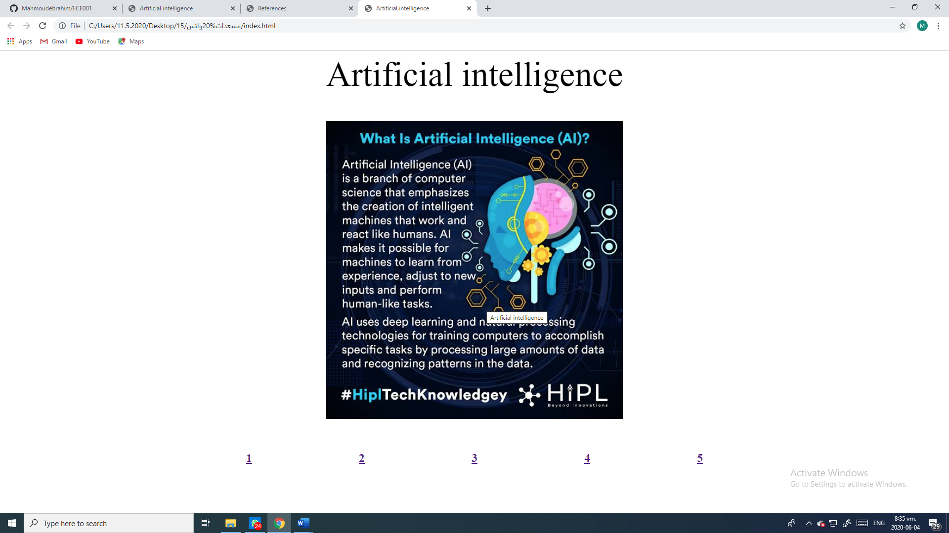

**بنھا**

**جامعة**

**بشبرا**

**الھندسة**

**كلية**

**الجامعي**

**العام**

**٢٠١٩**

**-**

**٢٠٢٠**



source code:- 

page2:- 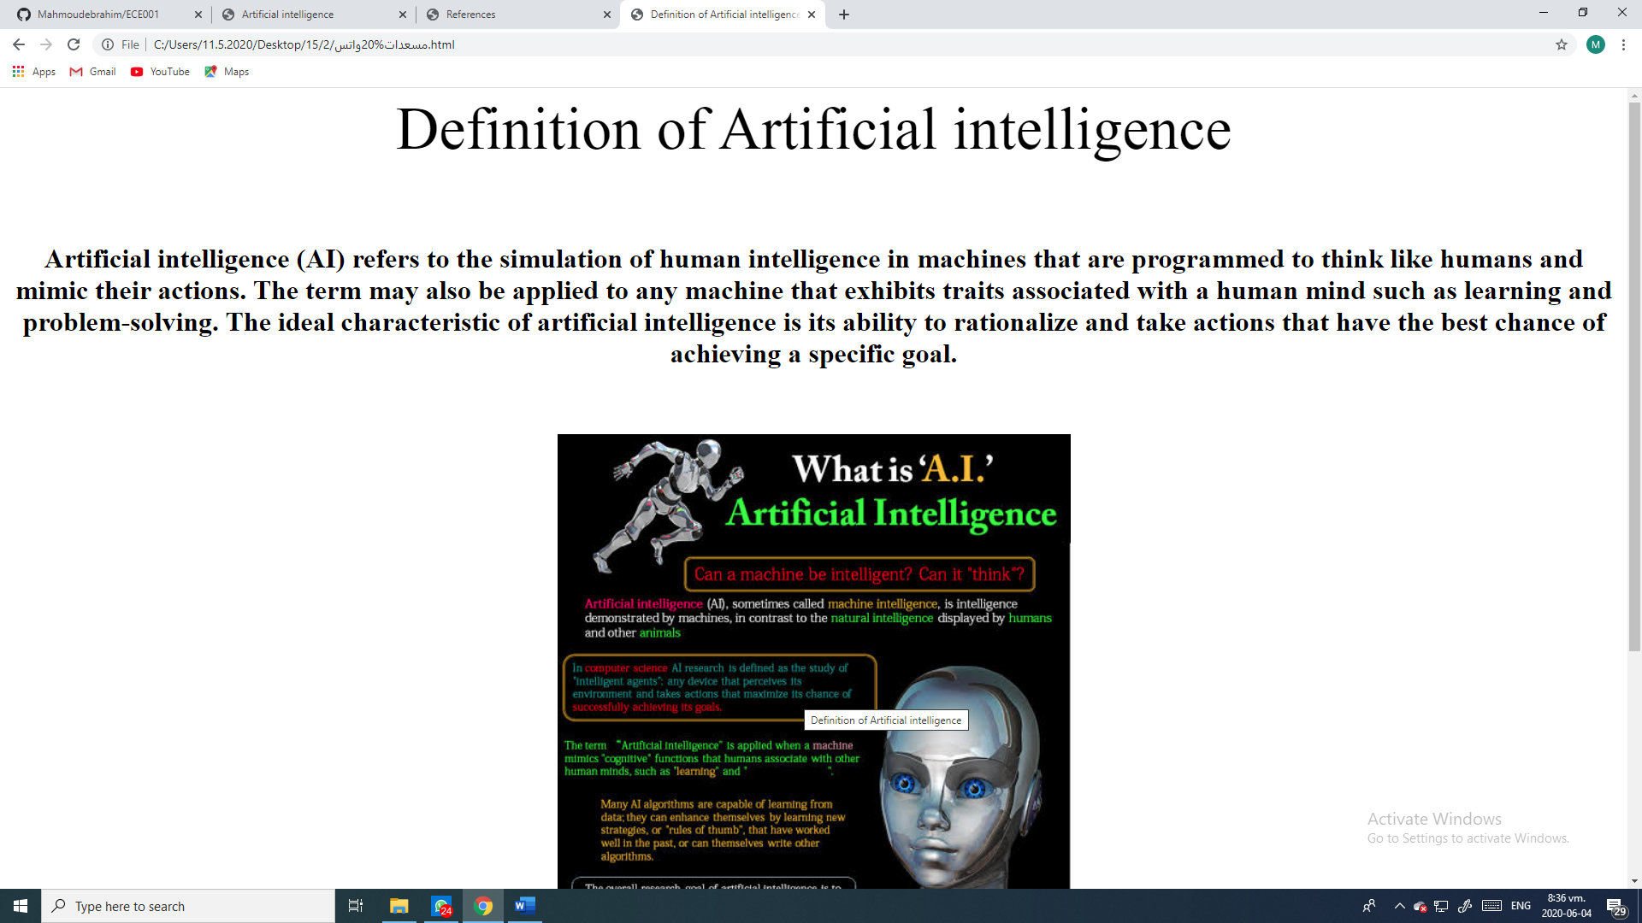 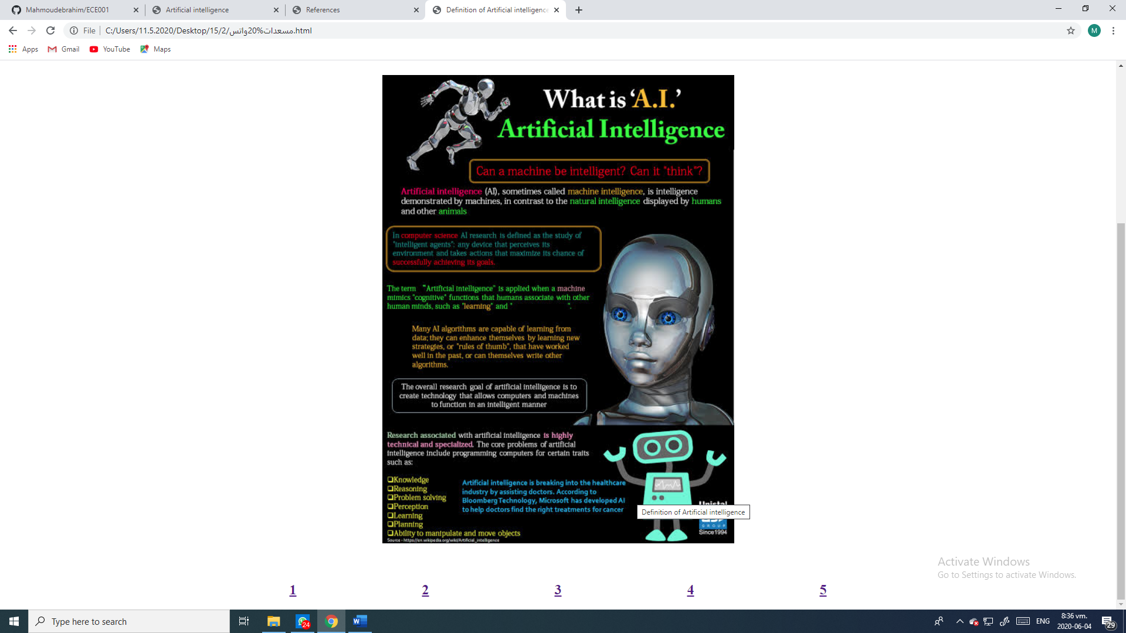

source code:- 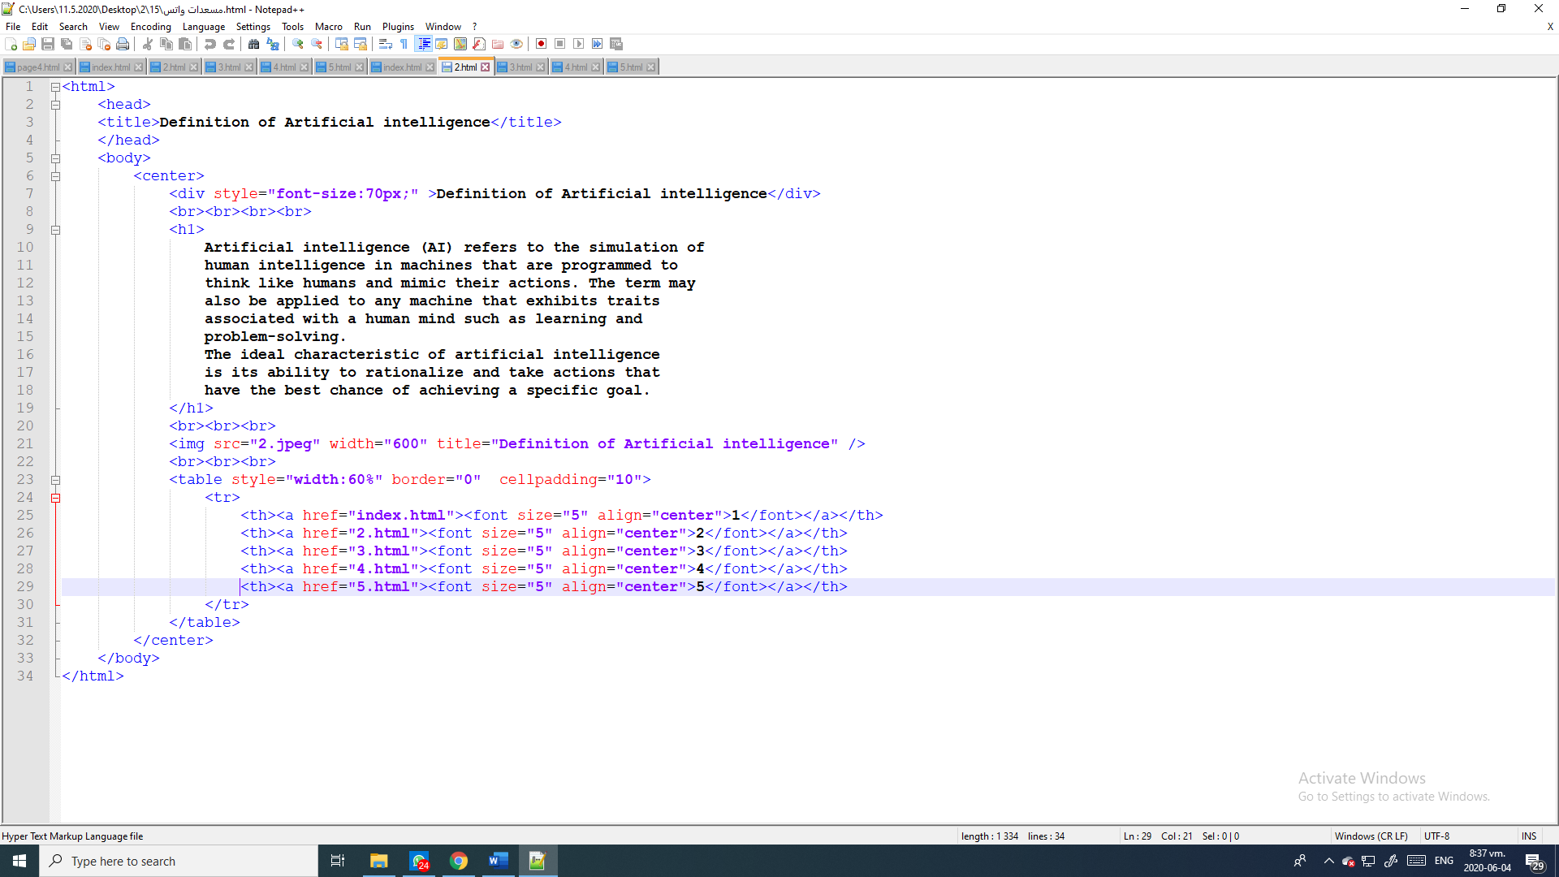

page3:- 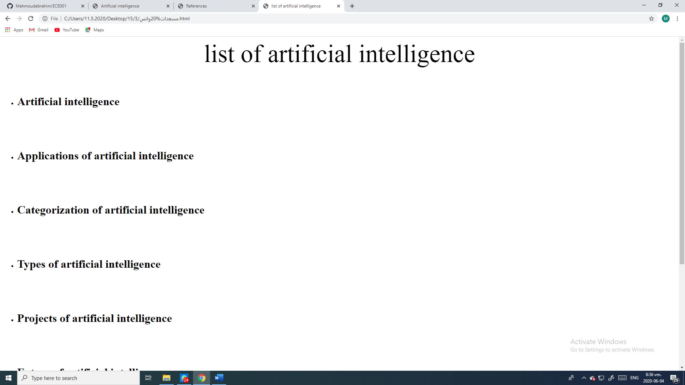 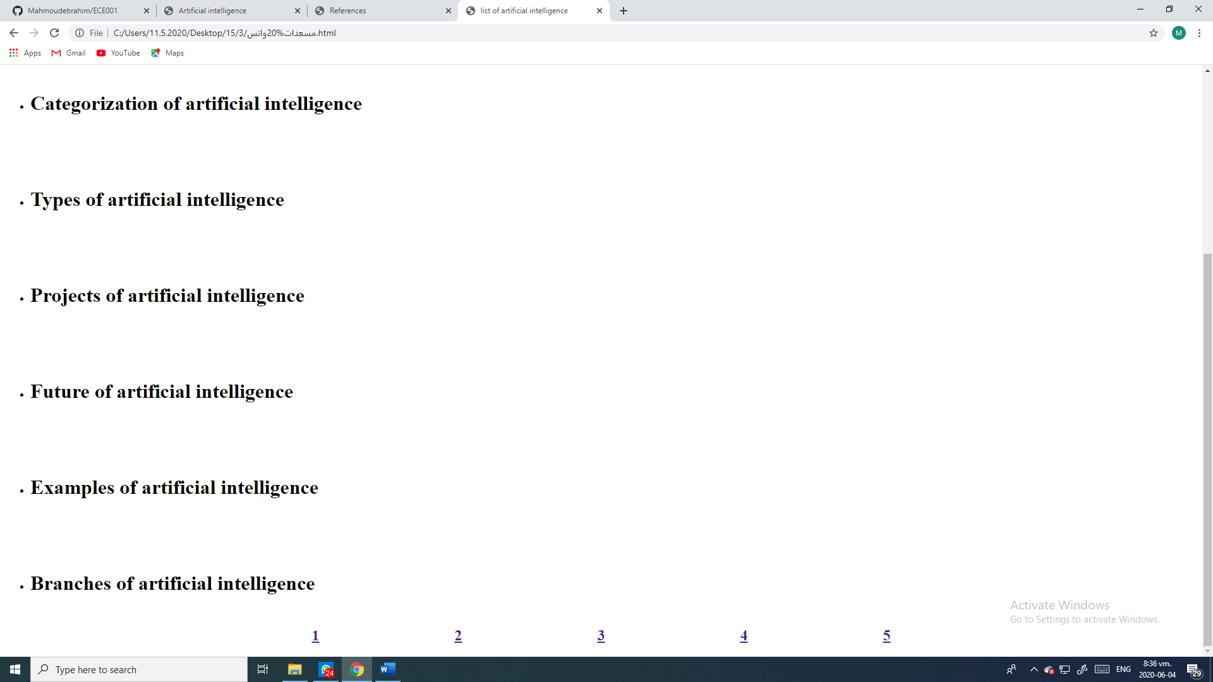

source code:- 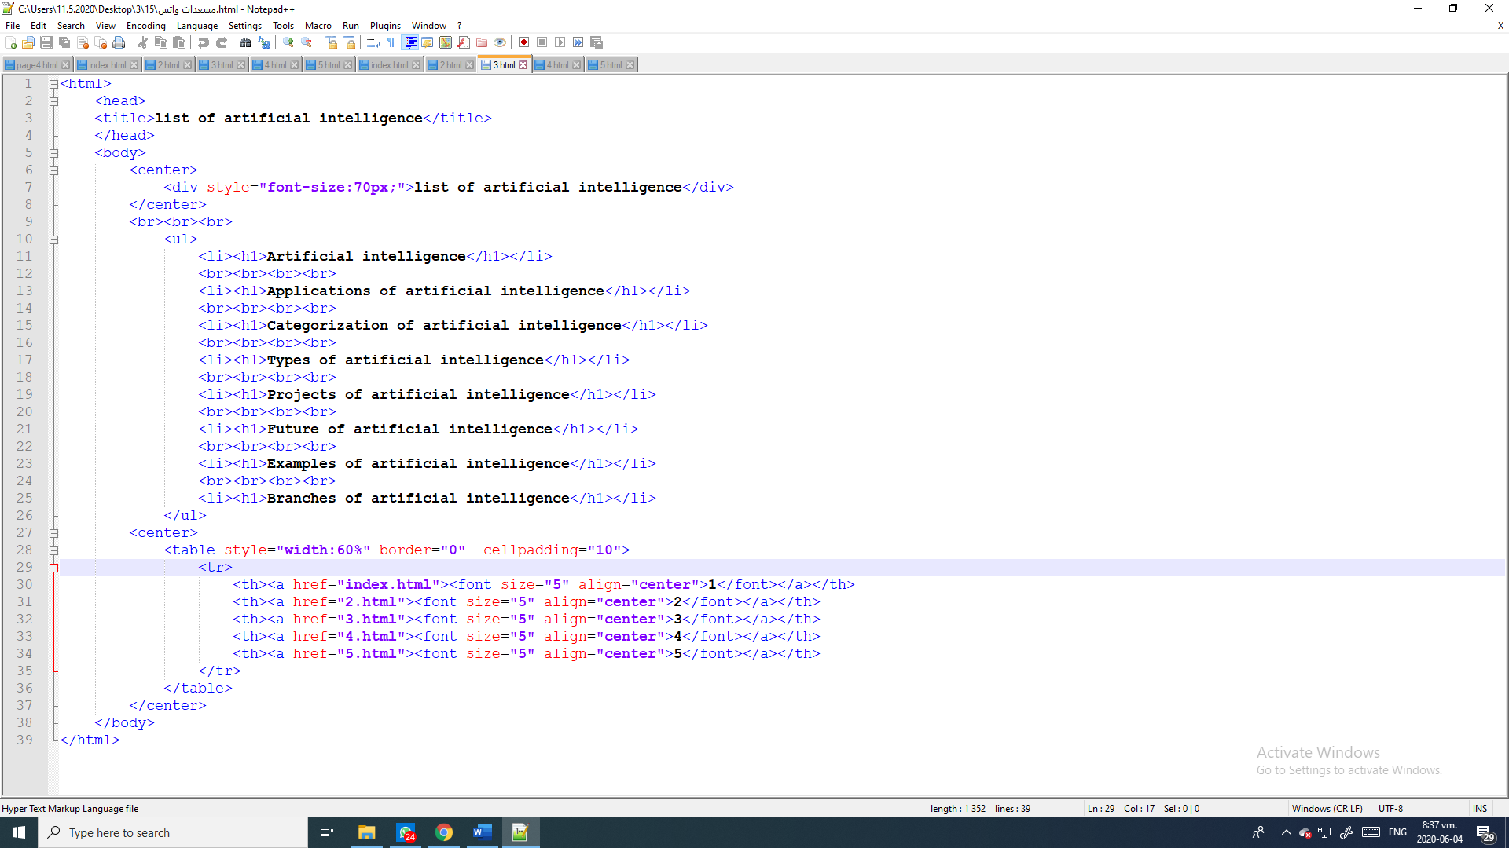

page4:- 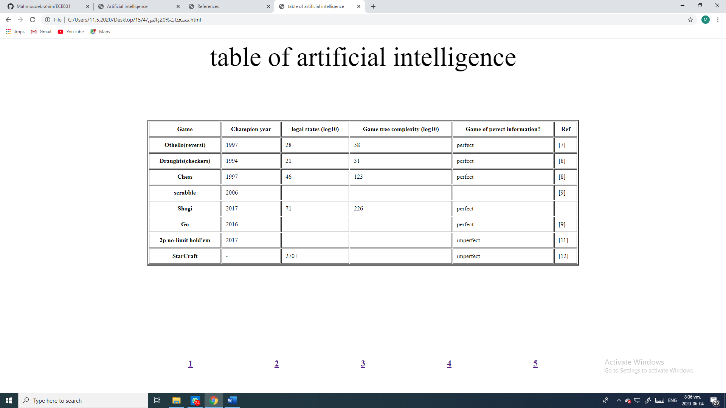

source code:- 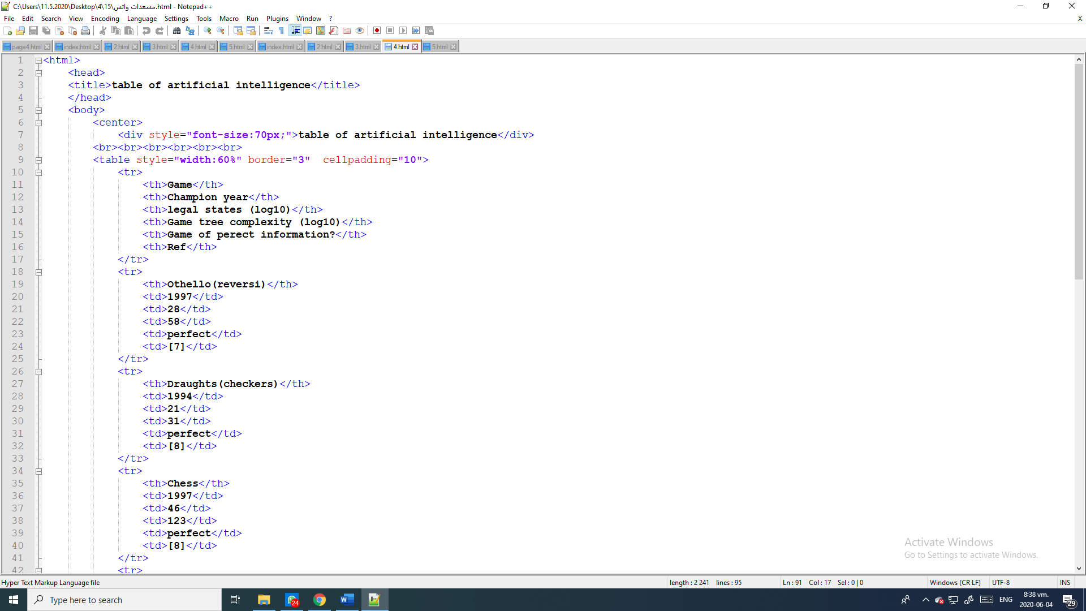  

page5:- 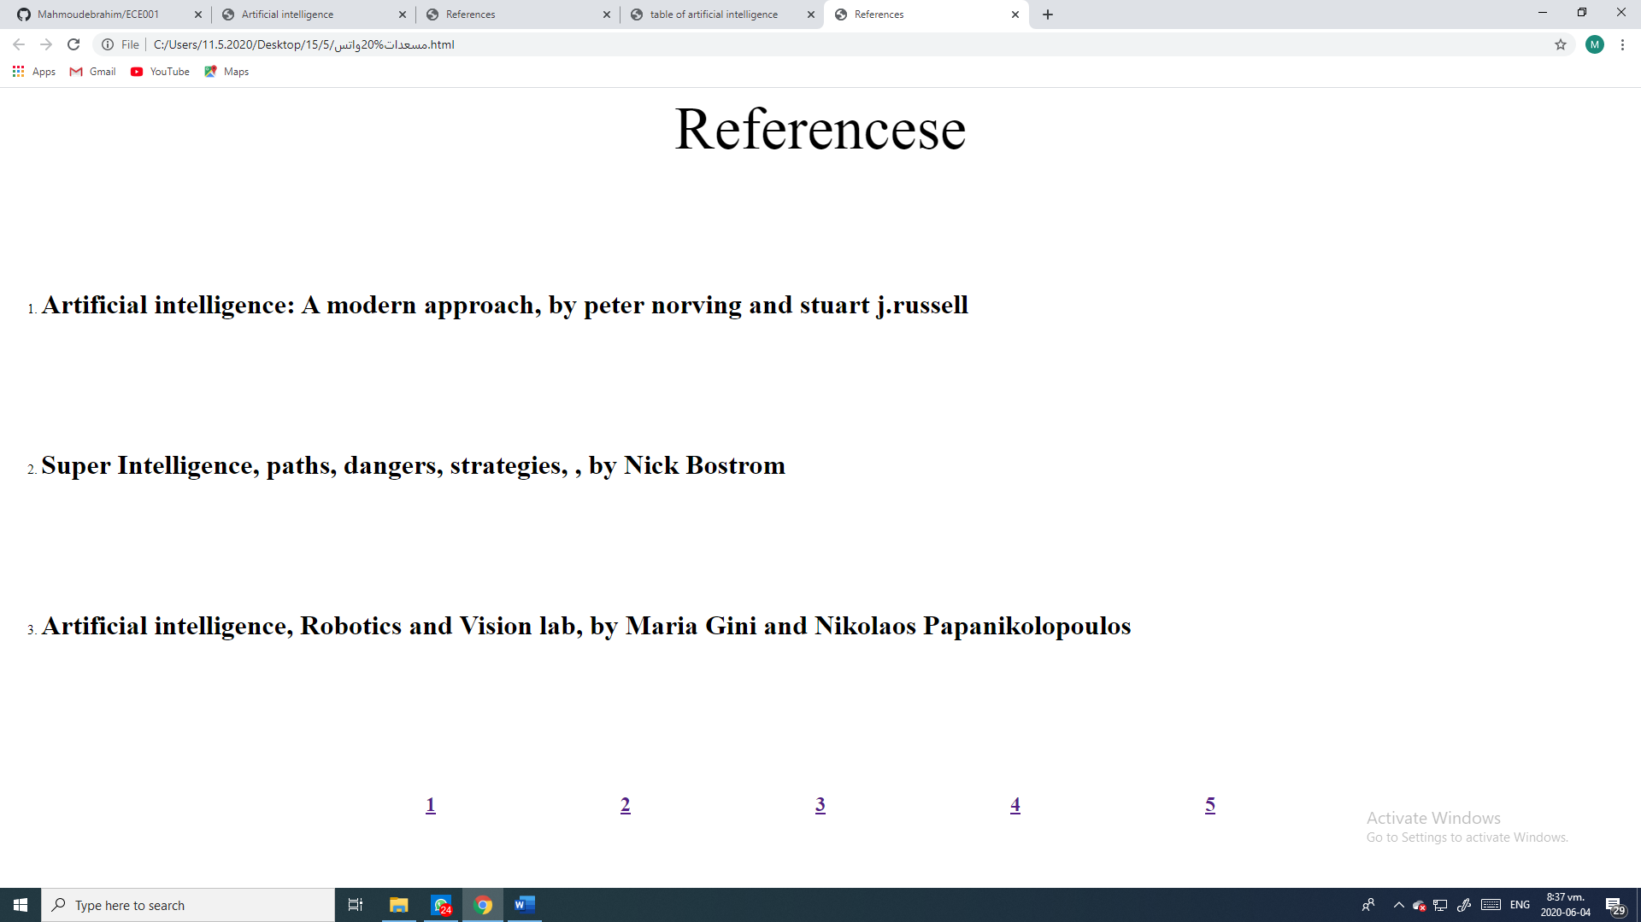

source code:- 